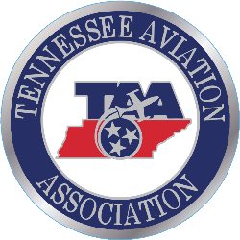
TN AVIATION ASSOCIATION
30th TN AIRPORT CONFERENCE
GOLF TOURNAMENT
Wednesday, April 18, 2018
Sevierville Convention Center (The River Course)
Schedule – Lunch provided 11:00 am to 12:00 pm. Noon – Tournament begins.
Format – 4 – person scramble, players may form their own teams.
Entry Forms – Please complete and email this form to Jon Glass at taa@lighttube.net
Deadline – April 11, 2018.
Prizes will be awarded to the 1st, 2nd and 3rd place teams.
Sponsorships – Eastern Aviation is the main sponsor. Hole sponsorships are available for $150.00. Contact Jon Glass at (931) 581-5111 or taa@lighttube.net if interested.
NAME | PHONE | E-Mail

TEAM NAME _____________________________

